Dam it! A Cyberlearning Framework

INTRODUCTION

Dam it! Is a proposal for a cyberlearning experience for an authentic learning context comprising formal and informal, face-to-face and online learning activities. The “Dam It!” eight-week connected curriculum unit for Semester 1, Term 2, 2009, will be implemented in a single classroom with interactive whiteboard and six PCs with Internet access, and access to a lab of 30 computers in the library.

The intended learners are 25 Year 4 students (including five students for whom English is a second or subsequent language) whose prior learning experiences include:
- cyber safety awareness lessons related to the CyberQuoll website
- writing information narratives about habitats, lifecycles and food webs of Australian animals
- learning about the properties of water and the water cycle, and how landforms, rivers and other bodies of water are formed
- using discussion boards in the Year 4 virtual classroom on school SharePoint intranet, and a BlackBoard virtual classroom in The Learning Place.

Motivation for the unit comes from the students’ interest in issues related to recent water shortages in Queensland communities and social and environmental issues related to potential solutions.

PEDAGOGICAL APPROACH
A blended learning approach combining on- and off-line activities, focused teaching, student-initiated research, on-line experimentation, off-line investigation and guided discussions will be used.

The online experiential learning opportunities provided by co-constructing a WetPaint wiki are underpinned by social constructivism and connectivism. In the online learning environment, students and the teacher (in the role of Danny Dammit) develop their understandings of the impacts of different forms of land use on individuals, groups and ecosystems, as they collaboratively construct a local area information site and debate proposals for change.

An authentic application for their learning is provided by the following learning pretext, where the teacher assumes the role of Danny Dammit.
Danny Dammit, the nine-year-old son of an Australian engineer who is soon leaving to work overseas, has come to stay with his grandmother in our local area. He has said goodbye to his friends and begun homeschooling. Danny is lonely, so his grandmother encourages him to establish a blog (simulated in a WetPaint wiki) to learn about the local area and make online friends. Danny posts photos, asks questions about the local area, and invites students at the local school (our class) to join his online community.
Figure 1: Conceptual Schema for Online Learning Environment depicts the main components of the e-Learning environment —Management Tools, Content and Collaboration and Communication. See Appendix A – E-Learning Environment Conceptual Framework for more detail.
Figure 1: Conceptual Schema for Online Learning Environment
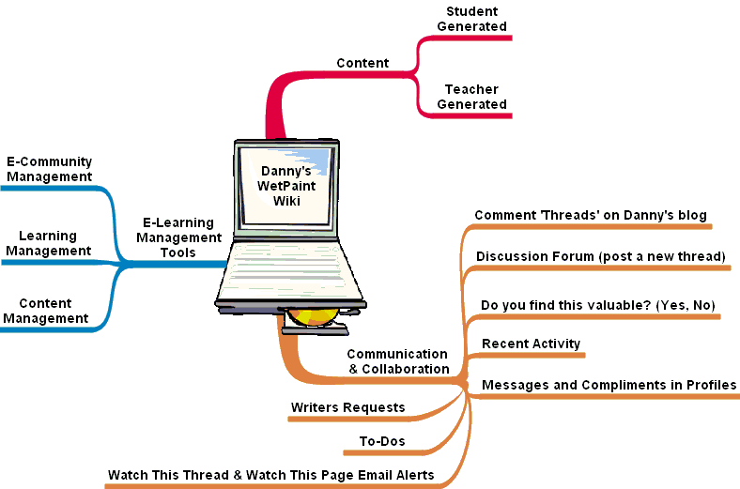

LEARNING OPPORTUNTIES and ASSESSMENT
Students are working towards demonstrating By Year 5 Learning Essentials in English, Science, Studies of Society and Environment, Technology and The Arts (listed in the table in Appendix B — “Dam It!” Learning & Assessment Rubric) as they explore local area land use and care to identify how:
- attitudes and actions determine ways the land is used and cared for by people, and
- the way people use the land affects individuals, groups, and ecosystems.

Students respond to Danny’s requests for local area information, and comment on his posts and photos. Their collective efforts result in an online resource about the local area, past and present uses of Kedron Brook and Kalinga Park, land care strategies, and who is responsible for its care.

As the students’ understanding of the history of local area land use and care grows, Danny proposes a series of local area initiatives for debate — who benefits and who is disadvantaged. He encourages the students to come up with alternates.
Proposals investigated might include:
- damming Kedron Brook to increase freshwater supplies or create a water park
- building more bridges across Kedron Brook to increase access to Kalinga Park
- constructing a desalination plant at the Kedron Brook Floodway.

Curriculum negotiation is achieved by allowing students to choose:
- aspects of the local area and proposals they would like to research
- roles they will assume when responding to proposals (e.g. from the points of view of children, one of the groups who currently use the park for organised activities, local residents who use the park for recreation, environmentalists, Brisbane City Council representatives, local business owners, developers or contractors)
- data collection methods (e.g. through research, interviews, online surveys and/or impact studies) to find evidence to back up their arguments
- assessment item/s to complete (e.g. newspaper report; information narrative; radio interview with a politician, or role play of an altercation between stakeholders).

The table in Figure 2: Unit Overview presents an overview of the balance between on- and off-line activities and teacher-directed and student-centred learning opportunities.
Figure 2: Unit Overview
 |  | Orientating | Synthesising | Enhancing
Offline | T-Directed | - Share texts.  - Introduce Socratic dialogue.  - Locate information.  - Plan impact study and interviews. | - Discuss Danny’s initial questions.  - Analyse news reports and information narratives.
Offline | S-Centred | - Create a futures wheel.  - Visit Kedron Brook and Kalinga Park, record images and conduct impact study.  - Role play town meeting about clearing mangroves.  - Interview family and friends. | - Interview local residents about Danny’s proposals.  - Participate in ‘In the Hot’ seat interviews.  - Role play a mock town meeting. | Individually or in groups:  - Draft a news report or information narrative related to one of Danny’s proposals.  - Prepare and present a mock radio interview or role play related to one of the proposals.
Online | T-Directed | - View Danny Dammit’s blog and join his social network.  - Compare Mary River and Kedron Brook catchments on Google Earth.  - Create and conduct an online survey. | - Analyse Save the Mary River website and other blogs and wikis.  - Discuss alternatives for gathering information about different points of view.
Online | S-Centred | - Comment on Danny’s photographs.  - Locate information.  - Respond to Danny’s questions.  - Experiment with the tools in WetPaint wikis and share what they discover. | - Conduct web searches.  - Conduct online surveys of local residents.  - Participate in and initiate online discussions.  - Design wiki pages and prepare images and text. | Individually or in groups:  - Add wiki pages and post local area information.  - Prepare and publish responses or alternatives to Danny’s proposals.  - Publish news reports, information narratives or performances.

A more detailed overview of learning experiences is provided in Appendix C — “Dam It!” Learning Experiences Overview.

Assessment is based on students’ participation in and contributions to:
- role plays
- e-forums (online discussions)
- comments and blog entries on Danny’s website
- web pages on Danny’s website
- written or spoken text.

RESOURCES
- TipCam, WetPaint, Google Maps and Google Earth, Survey Monkey
- websites about the local area, e.g. Brisbane City Council, Northgate Ward and Traveston Dam proposal
- Digital cameras for still and moving images

UNIT EVALUATION
Criteria for unit evaluation will relate to:
- quality and quantity of student engagement
- demonstrations the learning outcomes
- negotiating completion of the unit in the timeframe, and
- usability of online learning environment.

Students’ feedback will be sought through class discussion, “What I did” and “What I learnt” responses, and survey about the usability of the online environment.
APPENDIX A – E-LEARNING ENVIRONMENT CONCEPTUAL FRAMEWORK
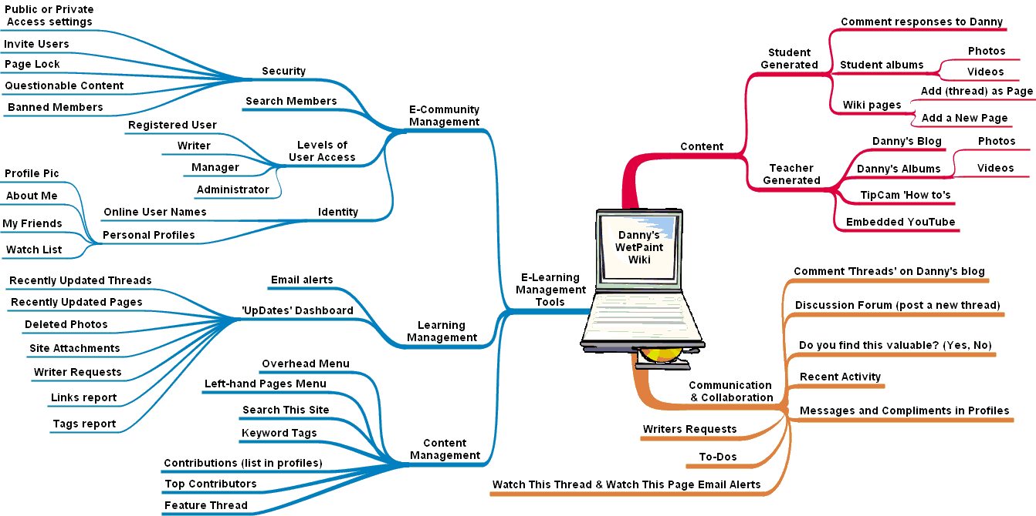
Danny’s WetPaint Wiki Conceptual Framework Key
E-Learning Management Tools  - E-Community Management  - Security  - Access settings - Public or Private  - 'Invite Users' facility  - 'Questionable Content' facility  - 'Page Lock' facility  - Banned Members List  - Identity  - Online user names  - Personal profiles  - Profile Pic  - About Me  - My Friends  - Watch List  - Levels of User Access  - Registered User  - Manager  - Administrator  - Writer  - Search members | - Learning Management  - Email alerts  - 'UpDates' Dashboard  - Recently updated threads report  - Recently updated pages report  - Deleted photos report  - Site attachments report  - Writer requests report  - Links report  - Tags report  - Content Management  - Keyword Tags  - Top Contributors  - Feature Thread  - 'Search this site' facility  - Overhead menu  - Pages menu  - Contributions list in profiles | Content  - Teacher Generated  - Danny's Blog  - Danny's Albums  - Photos  - Videos  - TipCam 'How to's  - Embedded YouTube  - Student Generated  - Comment responses to Danny  - Wiki pages  - Add (thread) as page facility  - Add a New Page facility  - Student albums  - Photos  - Videos | Communication & Collaboration  - Comment 'Threads' on Danny's blog  - Do you find this valuable? (Yes, No)  - Recent Activity report  - Discussion Forum (post a new thread)  - Watch this Thread and Watch this Page Email alerts  - To-Dos  - Writers Requests  - Messages and Compliments in Profiles

APPENDIX B — ‘DAM IT!’ LEARNING & ASSESSMENT RUBRIC
This rubric is designed under the assumption that students achieving an ‘A’ result will have responded to more than one of Danny’s proposal and/or responded to proposals from the point of view of more than one individual or group, have taken a lead role in research and design and worked with still and moving images.
Learning Essentials | A | B | C | D
ENGLISH  Speaking and listening  - Speakers can adopt different roles, and make language choices appropriate to the level of formality.  - Active listeners identify the topic, main ideas and opinions, retell information accurately, ask clarifying questions and volunteer information.  - Speakers and listeners use a number of strategies to make meaning, including identifying purpose, activating prior knowledge, responding, questioning, identifying main ideas, monitoring, summarising and reflecting.  - Conventions for turn-taking and interruption are used differently, depending on the context.  Writing and designing  - Writers and designers can adopt different roles, and make language choices appropriate to the audience.  - Writers and designers refer to authoritative sources and use a number of active writing strategies, including planning, drafting, revising, editing, proofreading, publishing and reflecting.  Literary and non-literary texts  - Aspects of subject matter can be included or omitted to present a point of view.  - Reports and arguments have structures, including an introduction or a general statement, elaboration of information or reasons, and a conclusion.  - Main ideas are established by identifying who, what, where, when, how and why. | WRITTEN AND SPOKE TEXTS  - Always observes conventions for turn-taking, accurately identifies topic, main ideas and opinions in retells, asks insightful open-ended questions to seek clarification, and succinctly and confidently provides accurate information in discussions.  - Publishes succinct well structured and descriptive recounts of local land use, identifying who, what, where, how and why.  - Presents the points of view of different land users in discussions and arguments. Effectively persuades the audience by using emotive language, and strategically omitted information and well-worded general statements backed up by accurate items of specific evidence. | WRITTEN AND SPOKE TEXTS  - Usually observes conventions for turn-taking, identifies topic, most main ideas and opinions in retells, asks useful questions to seek clarification, and provides relevant information in discussions.  - Publishes well-structured recounts of local land use, identifying who, what, where, how and why.  - Presents the points of view of different land users in discussions and arguments. Often uses emotive language, and backs up general statements with specific items of evidence to persuade the audience. | WRITTEN AND SPOKE TEXTS  - Usually Observes conventions for turn-taking, identifies topic, some main ideas and some opinions in retells, asks questions to seek clarification, and provides some relevant information in discussions.  - Publishes recounts of local land use, identifying who, what, where, how and why.  - Presents the points of view of different land users in discussions and arguments. Uses some emotive language and includes relevant general statements which are sometimes backed up by specific items of evidence to persuade the audience. | WRITTEN AND SPOKE TEXTS  - Sometimes observes conventions for turn-taking. Needs assistance to identifies topic, main ideas and opinions in retells. Rarely asks questions to seek clarification. Is hesitant to provide information in discussions, or adds irrelevant information.  - Publishes recounts of local land use, that identify most of who, what, where, how and why.  - Presents the point of view of a specific land user (generally her/himself) in discussions and arguments, generally using little emotive language, and simple general statements to persuade the audience.
SOSE  - PS 3.2 Interactions between people and places affect the physical features of the land, biodiversity, water and atmosphere.  - PS 3.6 Sustainability of local natural, social and built environments can be influenced by positive and negative attitudes and behaviours. | - Clearly and logically identifies a range of probable environmental impacts of proposed local area initiatives, and identifies probable benefits or disadvantages for individuals and groups (citing detailed and/or relevant evidence).  - Explains why people’s attitudes towards land use and care might change, and identifies how changing attitudes affected land use and care. | - Identifies a range of possible impacts on the environment of proposed local area initiatives, and identifies possible benefits or disadvantages for individuals and groups (citing some evidence from past events).  - Gives examples of how people’s changing attitudes have affected the ways in which the land is used. | - Identifies how a proposed local area initiative might impact on the environment, and explains how an individual or group might benefit or be disadvantaged.  - Explains how the local environment has changed to provide for the needs and wants of people. | - Sometimes identifies how proposed local area initiatives might impact on the environment, and explains how she/he may benefit or be disadvantaged.  - Gives examples of how she/he can care for the land.
SCIENCE  - EB 3.2 Changes to the surface of the earth or the atmosphere have identifiable causes, including human and natural activity. | - Clearly and logically explains and predicts cause and effect relationships between human and natural activities, including those related to floods, droughts and dam and bridge construction. | - Explains and predicts cause and effect relationships between human and natural activities, including those related to floods, droughts and dam and/or bridge construction. | - Identifies and predicts some cause and effect relationships between human and natural activities, including those related to floods, droughts and dam or bridge construction. | - Identifies some cause and effect relationships between human and natural activities, including those related to floods, droughts and dam or bridge construction.
TECHNOLOGY  - THE 3.1 Different ideas for designs and products are developed to meet needs and wants of people, their communities and environments.  - IMS 3.1 Resources have particular characteristics that make them more suitable for a specific purpose and context. | - Uses a range of visually pleasing and logical formats to present information about the local area.  - Selects a variety of relevant, thought-provoking information and still and moving images to persuade an audience to a particular point of view. | - Uses a visually pleasing logical format to present information.  - Selects relevant and interesting information and images to persuade an audience to a particular point of view. | - Presents information in a visually pleasing format.  - Selects some relevant information and interesting images related to a particular point of view. | - Presents limited information.  - Selects some information and images related to their point of view.
THE ARTS  - DR 3.1 Role and status of relationships can be maintained using movement, including posture, gesture and body position, and expression of voice.  - ME 3.2 Media techniques and practices, including layout, storyboard and manipulation of images, sounds and words, are used to create media texts. | - Uses a range of appropriate posture, gesture, body position, and vocal expression effectively to convey the role and status of her/his character in the town meeting debate.  - Chooses appropriate templates, tools, and relevant thought-provoking text and images to effectively present information and ideas about local area land use and care in interesting ways. | - Generally uses appropriate posture, gesture and body position, and expression of voice to convey the role and status of her/his character in the town meeting debate.  - Chooses an appropriate page template and relevant text and images to present information and ideas about local area land use and care. | - Makes some use of posture, gesture and body position, and/or expression of voice to depict the role and status of her/his character in the town meeting debate.  - Chooses relevant text and images to present information and ideas about local area land use. | - With prompting, makes some use of posture, gesture and body position, and/or expression of voice to depict the role and status of her/his character in the town meeting debate.  - Choose text and images related to local area land use.

APPENDIX C — ‘DAM IT!’ LEARNING ACTIVITIES OVERVIEW
This table presents an overview of off- and on-line learning experiences.
 | Off-line | On-line
Orientating | - Share texts (e.g. I Saw Nothing and I did Nothing by Gary Crew, and Pannikin and Pinta, by Colin Thiele) and discuss use of emotive language and images to persuade audiences.  - Read “The Mangrove Grannies” and complete a futures wheel for clearing the mangroves.  - Introduce to a simple form of Socratic dialogue and discuss issues related to clearing the mangroves.  - Locate information about local area landmarks by reading local area fact sheets.  - Visit Kedron Brook and Kalinga Park to photograph and observe the Brook flora and fauna and park facilities, and conduct a land use survey (identify features of the area, impact of human habitation, signs of erosion and preventative measures adopted).  - Plan and enact a class role play of a town meeting about the proposed clearing of the mangroves.  - Discuss what Danny might want to know about the creek, and why.  - Interview family and friends about the name of the creek and its origin and use of the park. | - View Danny Dammit’s blog and join his social network.  - Comment on Danny’s local area photographs (including those of the Boondal wetlands).  - Locate information to answer Danny’s questions on Brisbane City Council and local area websites to.  - View the Mary River and Kedron Brook catchments on Google Earth and discuss similarities and differences.  - Create and conduct an online survey (whole class activity).  - Experiment with the tools in WetPaint wikis and share what they discover with the class.  - Respond to Danny’s blog entries by posting answers to his questions about Kedron Brook and Kalinga Park.
Enhancing | - Analyse of news reports and information narratives (discuss the audiences, purpose, generic structure, emotive language and points of view presented; use functional grammar to analyse the texts).  - Use functional grammar to analyse the texts to see how language (e.g. emotive language) has been used to influence audiences.  - Interview local residents about Danny’s proposals.  - Engage in drama activities including ‘In the Hot’ seat interviews of students or teacher in role as Danny; and role playing a mock town meeting to discuss Danny’s proposal where students take on the roles of a variety of stakeholders. | - Add pages (individually and in groups) and post local area information and images on Danny’s site.  - View Save the Mary River website and other blogs and wikis that highlight environmental and discuss issues and points of view presented.  - Analyse site construction to identify the audiences, purposes, generic structures, text features.  - Conduct a web search for news articles related to similar proposals to discuss the issues raised.  - Create and conduct online surveys to find out points of view of various groups of people.  - Respond to Danny’s proposals in online discussions.
Synthesising | - Write and publish a news report about one of Danny’s proposals.  - Write and publish an information narrative about tensions created in the local community by one of Danny’s proposals.  - Prepare interview questions and answers and present a mock radio interview with a politician or developer.  - Prepare and present a role play of an altercation between environmentalists and developers. | - Individually or in small groups, design and construct a page for Danny’s site that promotes a particular point of view about one of Danny’s proposals.  - Publish news reports, information narratives and performances online.

